Section1: Use a HashSet to hold Employee Objects. Upon running the applications, the details of the employees added to the HashSet should be displayed.

Employee<<class>>

|--Id

|--name

|--salary

|--department

|--displayDetails()

Feel free to add properties and methods to Employee Class

Note: If we try to store any object other than Employee Object in HashSet, we should not be allowed to.

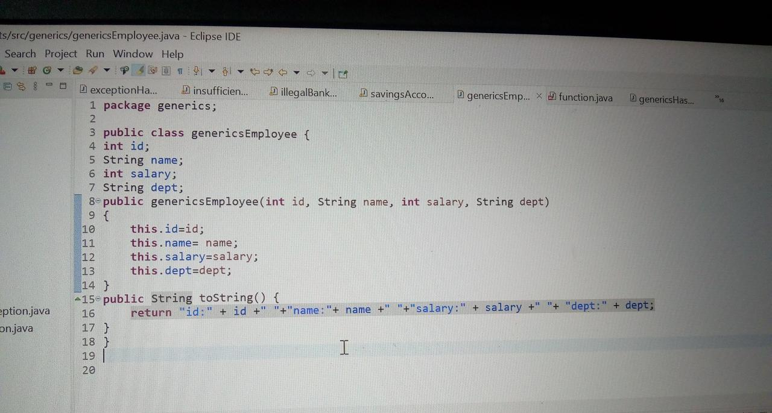

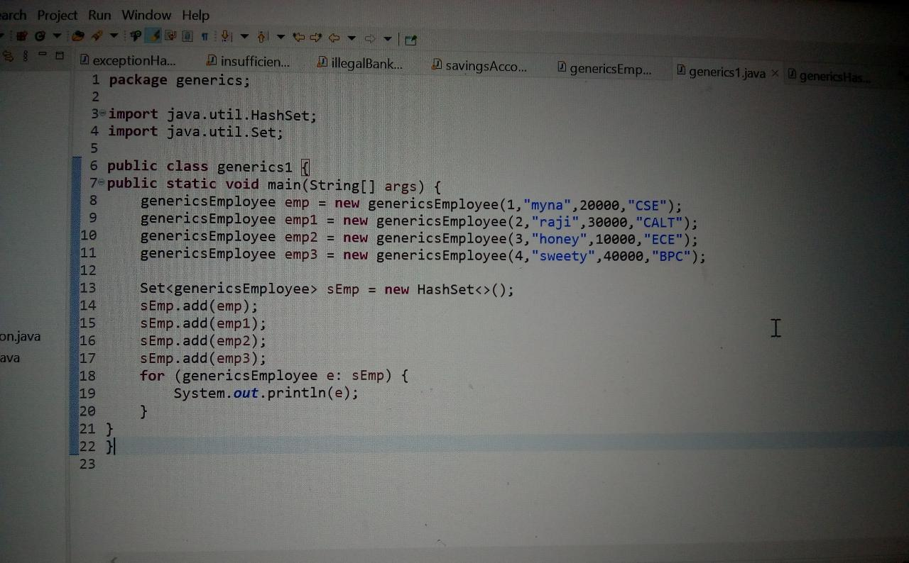

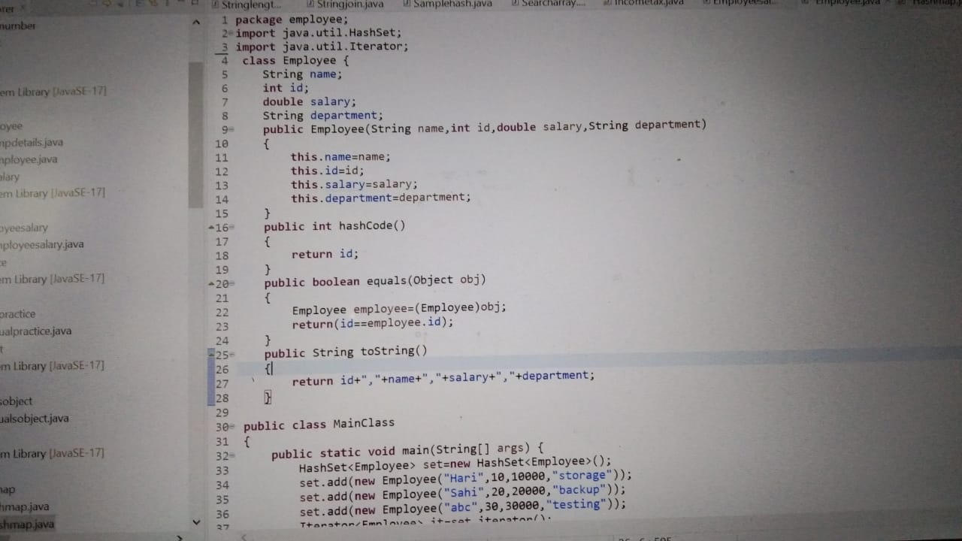

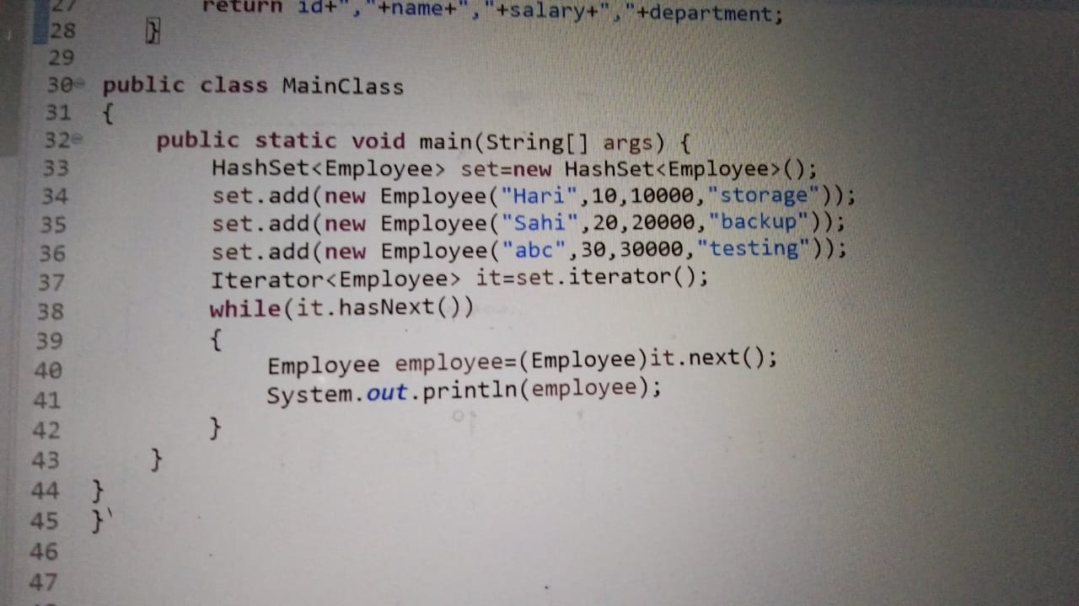

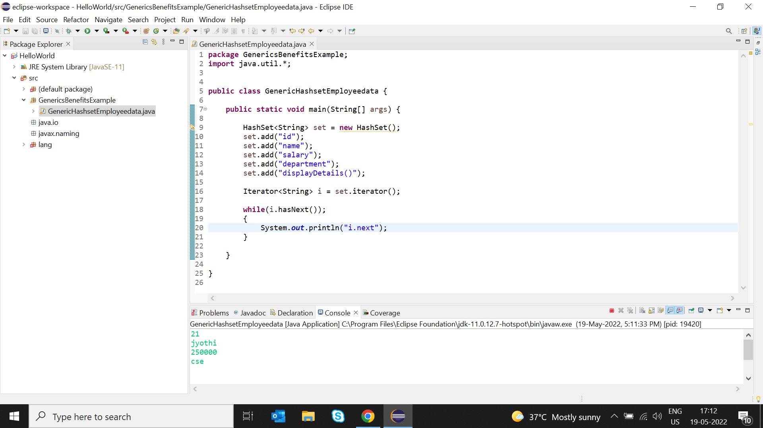

Section2: Write an application to hold 10 random int values as keys and 10 random double value as values for a HashMap. Print the data store in the HashMap. Note: Keys can only be int and values double.

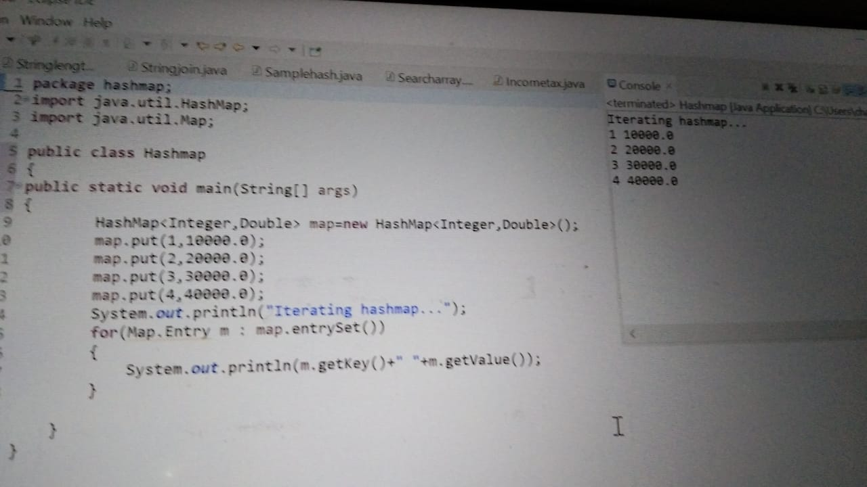

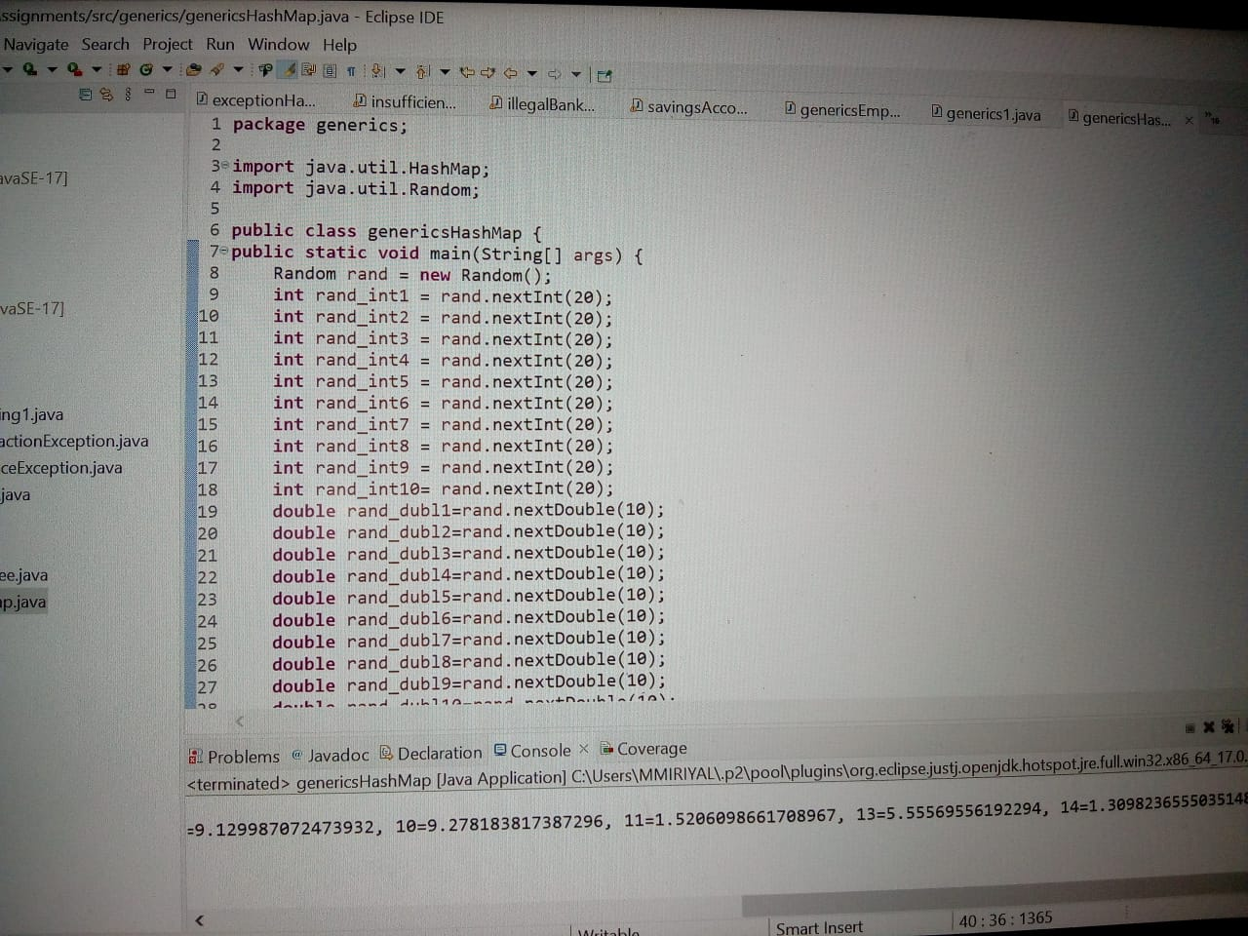

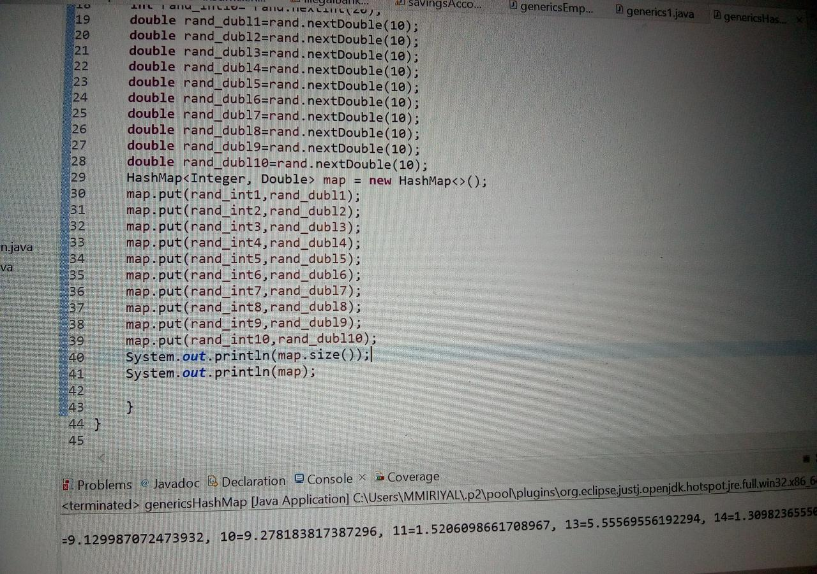

Section3: Write a generic method to exchange the position of two different elements in an array.

